F-POD Software Guide
Nov 2023
Background: PODs monitor the presence and activity of dolphins, porpoises and other toothed whales by the detection within the FPOD app of the ‘trains’ of echo-location clicks that they make. This gives them much lower false positive rates than can be achieved by identifying the characteristics of individual clicks, whether in wav files or other formats. There is more on the F-POD, the older C-POD, and relevant aspects of acoustics, in several PowerPoint presentations that can be accessed on the Chelonia website (www.chelonia.co.uk).
Feedback on this guide, and on any aspect of the instrument, is hugely valuable to us and to all users, so please don’t hesitate to send comments, criticisms and questions to nick.tregenza@chelonia.co.uk

FPOD app: Installation and requirements:
The FPOD app ‘FPOD.exe’ runs under all versions of Windows. It requires a screen with a vertical resolution of at least 1080 pixels to display comfortably. On MACs FPOD.exe will run under “Parallels Desktop”.
FPOD.exe is in portable format so that it can be run without being installed. It is checked for viruses etc. when uploaded to the Chelonia website. Download FPOD.exe from www.chelonia.co.uk Place it in a folder wherever you like on your PC, or you can run it from a USB stick, an SD card or any other external drive. Deleting the file FPOD.exe is all that is required to remove it from your computer.
4K screen: strongly recommended, especially for validation work. Below 1024x768 the display is unsatisfactory.
💡 Help: the red text in the pale green bar at the top of the screen provides a brief note on what is under the mouse pointer. If it is over the ‘Delete file set’ button on the Filters +files page this is shown:

💡 Menu: this is shown or hidden by moving the mouse pointer up to the top of the FPOD app window and down again. Or clicking the large green label as above, or the small ‘menu’ button top left on the main screen.
💡 The FPOD app and upgrades are free. To ensure you are notified of upgrades join the mailing list via https://www.chelonia.co.uk/contact_us.htm
💡 F5, F6 etc are useful shortcuts. On some keyboards you can just press that key. On others you have to press the Fn key at the same time.
We also strongly recommend installing this SD card formatter: https://www.sdcard.org/downloads/formatter/ from the SD Association. It is more reliable than others and only ever formats SD cards!
Tips for users of earlier versions of FPOD.exe:
Favourite features
- A trend estimation tool is now included. This uses paired year ratio assessment (PYRA) and is useful for data sets of 3 years and longer.
- If you see something interesting in your data do CTRL + S and save a ‘comment’ or settings file with a really informative name like ‘Dolphin social downsweeps’ and you can then easily go back to view it on another day.
- You can play an audio representation of the rate of clicking shown on the screen. See the Display page info.
- Error estimation
- Minute filters can show you subsets minutes, e.g. those in which you have marked a species sighting.
- Validation sampling points –statistically appropriate positions for sampling data can be set and visited very easily.

Quick start

Starting, deploying and stopping the F-POD are described in the F-POD User Guide.
Getting a file from the SD card:
- On retrieval of an SD card, insert it into the SD card reader or directly into your PC.
- Run FPOD.exe:
> Show the menu
> select the Read SD tab
> enter the location name in section 1. This name is very important and must be used consistently for that site.
> add any deployment notes in section 2.
> click ‘Read F-POD SD card’ in section 3.
> select any file ending in .CHE on the SD card.
> select a directory for your files. 💡Keep all the files for a project in one directory. This really will save time and errors later.
The data will now be read, including later files (named F_DATA1.CHE etc.) and they will be converted to a number of FP1 files - their maximum size is set on the ReadSD page, so you can have huge single files if you wish:
- Do not put the POD number or date into the file name. These are added automatically in a tried and tested format that helps you handle and sort large numbers of files.
- Think carefully about how to name sites. For long term trend estimation a site that is more than 200m from another needs a different name.
- Do not put your POD files in many separate directories unless your project is very small.

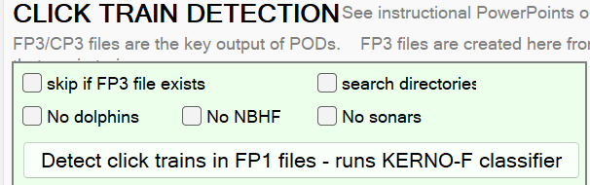
Getting an FP3 file from the FP1 file:
Process the FP1 files through the KERNO-F classifier by going to the Trains page of the menu and clicking ‘Detect click trains in FP1 files’
‘Skip if FP3 exists’ + ‘search directories’ lets you just pick the folder/directory where you have put the FP1.
This process will create an FP3 file for each FP1 file.
For river dolphins you may need to exclude NBHF and exclude sonars.

What settings should I use?
The standard settings for marine species are
Dolphins: 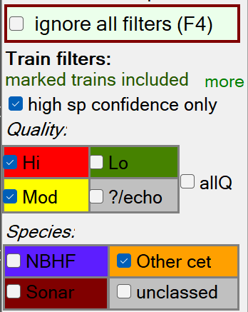 Porpoises: 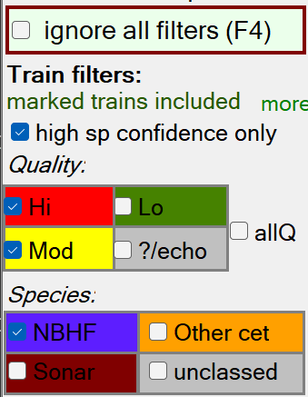
(but some dolphins make NBHF – narrow-band high-frequency) clicks.
River dolphins typically require train detection settings like these: (unless soanrs are common)
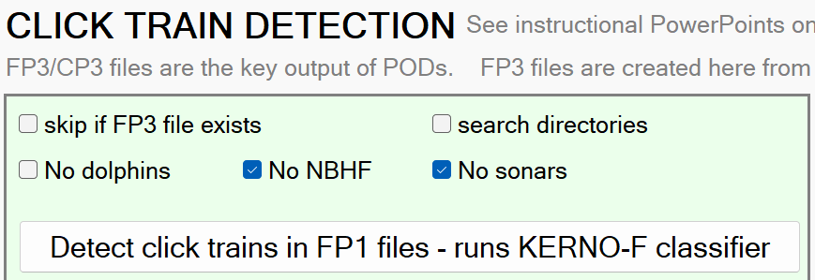
And then these species and Q class settings:
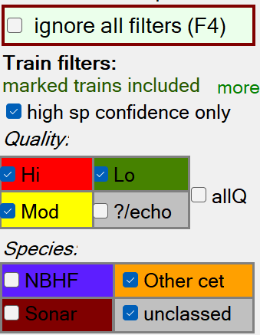
The results of using these filters needs to be validated.
Other filters can be applied to obtain a picture of the use of fast click trains etc.

Other resources:

Join the POD users mailing list here

Key reference and detailed description of validation process and F-POD functioning

Topic notes and glossary … at the end of this document

F-POD downloads

Chelonia’s Youtube channel has videos on numerous topics

PowerPoint presentations on these topics are available on the Chelonia website including these links
PODs and acoustics links to a set of resource videos / documents
Validation of F-POD data
F-POD version history

The FPOD app
What it does:

FPOD.exe converts the data stored on an SD card to two files:
- The FP1 file that holds all the clicks in raw data.
- The FP3 file that holds only clicks in click trains found by the KERNO-F classifier + information on the trains.
- … both file types hold information the angle of the POD to vertical and the temperature for each minute.
The classification process typically takes 1 minute per day of data.
The FPOD app contains many display tools and filters that are helpful in understanding the soundscape and cetacean click trains.
The FPOD app has flexible export tools to pass the data in various formats to spreadsheets, ‘R’ etc …
Finally, the app enables you to change the clock time and settings of any F-POD.

Files
On the SD card:
- A series of ‘…..CHE’ data files, one for each day (from recent F-PODs) up to 4GB. If no errors are reported and the FP1 file looks as expected and is backed up then you do a ‘quick format’ of the card, and it is read for re-use.
If a data series is already on an SD card the POD will create a new file series with different series number. Both series will be read, and given distinct names.
- F_SETS.txt – this gives the F-POD new operational settings that are retained even with no batteries. The F-POD always runs with the last settings it was given, so it is normaly run with blank SD cards.
- F_TIME.txt – this is a text file you can create via the Settings page of the menu to reset the F-POD to your local time.

On the PC:
- *.FP1 – data files generated when the SD card is read. They contain the clicks logged, the temperature and the angle off vertical upwards for each minute.
- *.FP3 - data files are generated when the FP1 file is processed via the button on the Trains page. They contain only the clicks that have been identified by the KERNO-F classifier as belonging to a train, each with a set of train descriptors. The FP3 file also holds some new minute descriptors on landmark sequences and ambient noise.
- a ‘File set’ refers to an FP1 file and the corresponding FP3 file. You can open multiple copies of each to view different parameters of each.
- *.f1m, *.f3m – these are map files that allow the app to move rapidly to any time, even in large files. These files must be in the same directory as the FP1 or FP3 file to be useful. If you delete them, No worries! they will be recreated if needed, so if you are in doubt you can discard them.
- *.txt – many export functions create text files that can be imported very easily into databases, spreadsheets and word-processors using copy and paste.
- *.arr – array files. These are large files generated from sets of FP3 files that have been named (or renamed) with their Y, X position on a rectangular grid, so that detections across the whole array can be displayed at speed.
- .fpf – filter settings files. These are text files that enable you to save and return very quickly to a particular view of a particular time in a particular file. Or just restore the filters you had in use...
- .fpe – export settings files. Similar file to restore the filters etc. you use for a particular data export.
- .fpt – train detection classifier settings files. Some NBHF species are different and need different settings for optimal detection performance. These hold those settings to enable them to be used without errors.

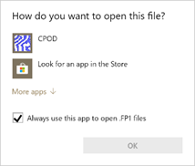
Associating PC file types with the FPOD app:
Right-click on an FP1 file and select ‘Open with ‘ Follow ‘More apps’ to find the FPOD app and check ‘Always use this app to open .FP1 files’ before clicking OK:
Repeat this for FP3 files.
When you have done this you can double-click a F-POD file name and FPOD will automatically run. The file will not open immediately, but when you proceed to ‘open files’ the file name and path will already be in the file name selection box.

Opening data files
The ‘Open files’ button / ‘Open file set’ button on the ‘Files’ page / clicking in the display area (if no file is open) all do the same thing: if you select any single .FP1 file or .FP3 file the app will try to open the number of copies of each type set in the boxes top right below. You can change these numbers. Use ‘Open up to 6 unrelated files’ to select files from more than one POD deployment. Opens C-POD files – you can mix C and F.
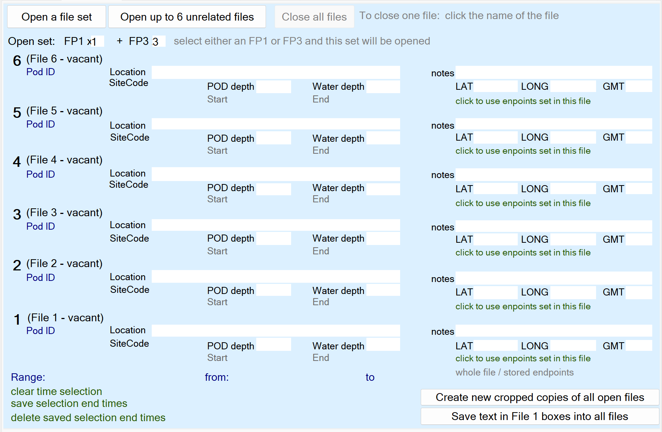
Array files are opened by the ‘Start array viewer’ button on the ‘view +’ page.

Cropping data files
Normally you need to remove the ends of the files – the times when the POD was not in the water, or the boat sonar was still being heard. This should be done once by the ‘data manager’ and the cropped FP1 file is then put in a folder called ‘Useful files’ which becomes the definitive data store for your project. All FP1 files from all sites and all years go into this one folder! Yes, it’s scary! … and some people hate the idea, but it works best.
To crop a file:
- Open a file set or just the FP1 file.
- Set a time selection enclosing the part you wish to retain – use the right-click pop-up menu.
- Click ‘Create new cropped copies of open files’. The original files are not altered.
- Note: the FP3 file holds a record of the total number of clicks in the FP1 file, but these will now refer to the original FP1 file. If you re-process the cropped FP1, then this value is corrected, and the file warnings are updated.

Time selections are also a way of limiting the time range of a file that is available for analysis or export. They can be saved into the file header, and used or changed subsequently. Or time selections can be set as a temporary measure to enable you to quickly analyse that subset of data.

The FPOD app – Data display

Up to 6 data files can viewed together, numbered from 1 to 6 as you go up from the bottom, and they will always be shown with the times in synchrony along the horizontal axis. You can have 6 views of the same file, or the same view of 6 different files, etc opened via the Files page of the menu.
High resolution: the time scale is 100ms or less per pixel. Details of each click are shown, but there may be more than 1 click within the time span of a pixel. These displays show the structure of click trains and often allow you to see surface echoes, multipath propagation, evidence of the structure of the click beam etc. You can also view some of the fine time domain structure of each click, and more detail of some clicks.
Low resolution: the time scale is 1min or higher – up to 10 days. The data shown is counts of clicks or features of the clicks within that group of 1 or more minutes, and is shown in columns 3 pixels wide. These displays show the pattern of use of the location over time, and often show tidal and seasonal influences, storms, boat traffic etc.
Extra info can be show, or hidden (via the Display page of the menu)
The angles of the POD to vertical are shown as short lines at the top of the file 1 panel and give evidence of storms, currents, and movement of the POD. Whole histories of deployments that went AWOL can sometimes be inferred.
A black line on FP1 files shows the average number of clicks logged per minute in each time period.
A green line on File 1 shows the operational threshold. The amplitude threshold steps up when large numbers of clicks are logged over a few minutes. This can be switched off or adjusted via the Settings.
The temperature is displayed for the first FP1 and FP3 as a black and white line. To get a listing of the temperatures go to the Export page of the menu and use the ‘Summary of displayed minutes’ button. This also gives you details of the battery voltages and which battery stack was in use, and the operational threshold in use.
Battery voltage levels can be displayed for file1 only. It’s the option at the bottom of the drop-down list for file1.

Zooming
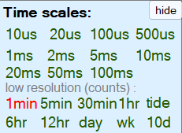
Select a new time scale by clicking one of these labels
Or:

Zoom in
- the keyboard down arrow: In the new view the time at the mouse pointer position will be moved to the centre of the screen.
or .. this is quicker for big changes:
- Left drag to right - a yellow line will appear showing the new range to be displayed. At the end of the drag the view zooms in to show it.
Zoom out
the keyboard up arrow. The new view has the time at the mouse pointer position at the centre of the screen.

Move earlier/later
the left arrow key shows data earlier than the pointer position
the left arrow key shows data after the pointer position

Data display – low resolution

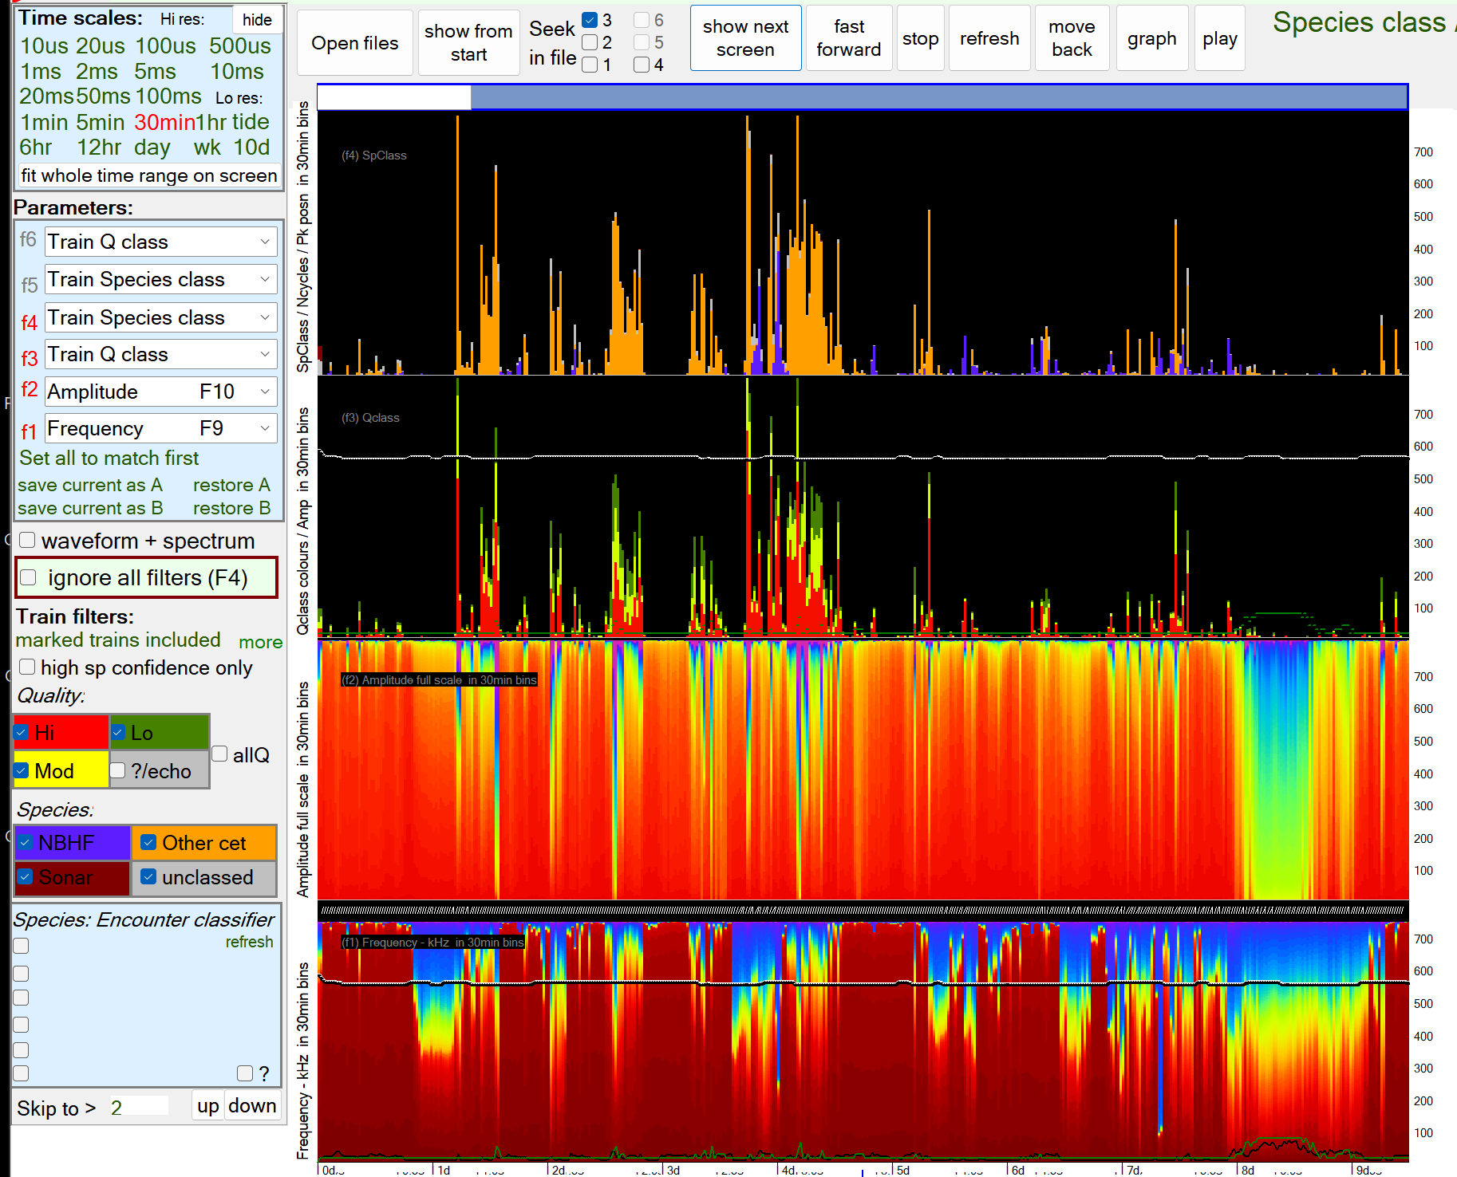

The hints shown in red in the green bar at the top explain the software item under the mouse pointer.
The document ‘Validation of F-POD data’ illustrates some of the ways you can use this display to understand what it going on.

Some useful features:
- Waveform + spectrum will show you details from those few clicks on which the wavelength and duration of every cycle have been logged.
- Ignore all filters: extremely useful in high res mode. You can filter for whatever you like and then use this to see the full context. F4 is the shortcut.
- ‘marked trains included’ Trains can be marked by putting the mouse pointer just to the left of the first click in the train and selecting from the right-click pop-up menu. The Filters +files page has more on this. Viewing and analysing ‘marked trains only’ is very useful for studying behaviours.
- high species confidence only: The default is checked = on = true. Turning it off give detection rates a few percent higher, but mostly it’s best to use the default setting – partly because you don’t have to remember to turn it off!
- Species encounter classifier: The C-POD had two: GENENC and Hel1. If an open file was been processed using one of these it will have the original KERNO classification plus a secondary classification using the named classifier that offers one or more species classes. If any of these are selected they over-ride the KERNO classifications.
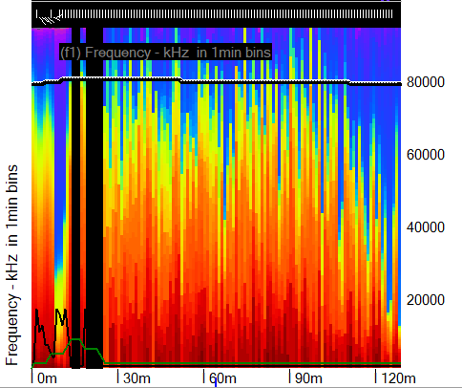
- The small white lines at the top show the angles to vertical of the POD. You can see the deployment.
- The black and white line shows the temperature rise on immersion – this is near Odessa on the Black Sea.
- The black line shows the average number of clicks per minute.
- The green line shows the operational threshold of the POD moving in real time in response to the rate at which clicks were logged.

- 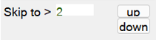 This sets the minimum number of clicks on a high res screen, so the time on display moves forwards until a screen is found with at least this number. Skipping in an FP3 file to, say 512 clicks, at a resolution of 5ms will typically show intense feeding activity or social activity.

Data display – High resolution
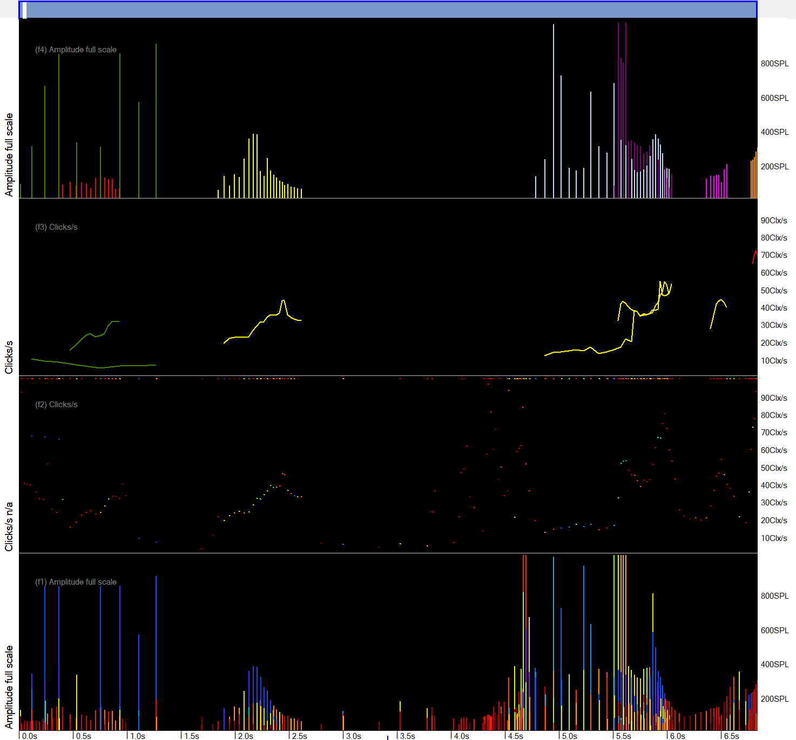

What is shown:
You can select any of these parameters to display from each of the open files:
Frequency | Colour coded: 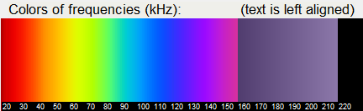
Amplitude | On an 8bit scale, 0..255, but this is compressed. Clipped clicks have extrapolated amplitudes. The default setting shows:
Clicks/sec | The reciprocal of the prior inter-click interval.
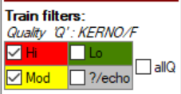  Train Q class | The Q class is the ‘quality’ of the train = the confidence of it’s coming from a true train source, as opposed to a being a chance sequence of similar clicks at similar intervals. Normally only Q High and Moderate are treated as reliable, but it may be of interest at times to look at the lower Q classes. The lowest, called doubtful or ‘?’ includes trains that really belong to a higher Q class but appear to be composed of echoes of a higher Q train. They are ‘down-classed’ to avoid double-counting of trains with echoes.
Train Species class  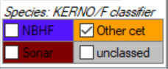 | NBHF = narrow band high frequency – this species group includes all porpoises, some dolphins and pygmy sperm whales.  ‘Other cet’ = all other cetaceans – dolphins, beaked whales, pilot whales etc.  ‘Sonar’ includes all sources that seem to be man-made.  ‘Unclassed’ these are trains with features that overlap two classes or lack any strongly discriminatory features.
NBHF index | A metric based on frequency, duration (= n of cycles), bandwidth, and the position of the loudest cycle within the click.
N of cycles | This is used in place of ‘duration’. It is the number of waves, = cycles, in the click.
Inter-click-interval | Where a click has been inferred (i.e. it wasn’t picked up as part of the train) the interval used  Takes into account the fact that the ICI is really two such intervals.
Bandwidth | An arbitrary scale derived from the variation in cycle periods and amplitudes within the click
Amplitude profile | The amplitude of a few cycle peaks around the loudest cycle.
Frequency profile | The frequency from the wavelength a few cycles around the loudest cycle.
Cluster size | The number of clicks identified as being part of the cluster of multipath replicates
Train WUTS risk | An estimate, of low accuracy, of the risk of this being a click train produced by a Weak Unknown Train Source.
Battery levels | Each battery stack is logged every minute
More details on these are in the document ‘FPOD click and train descriptions’.

Waveform display
Put a tick in the ‘waveform + spectrum’ box on the left side of the main display. You will then see a more detailed view of some clicks that have extra data saved. They are selected by a real-time train detection algorithm that is a simple but inaccurate method of selecting clicks for this special treatment. It does provide ‘voucher’ specimens of some clicks in many cetacean trains.
Here is the display of a click from a harbour porpoise: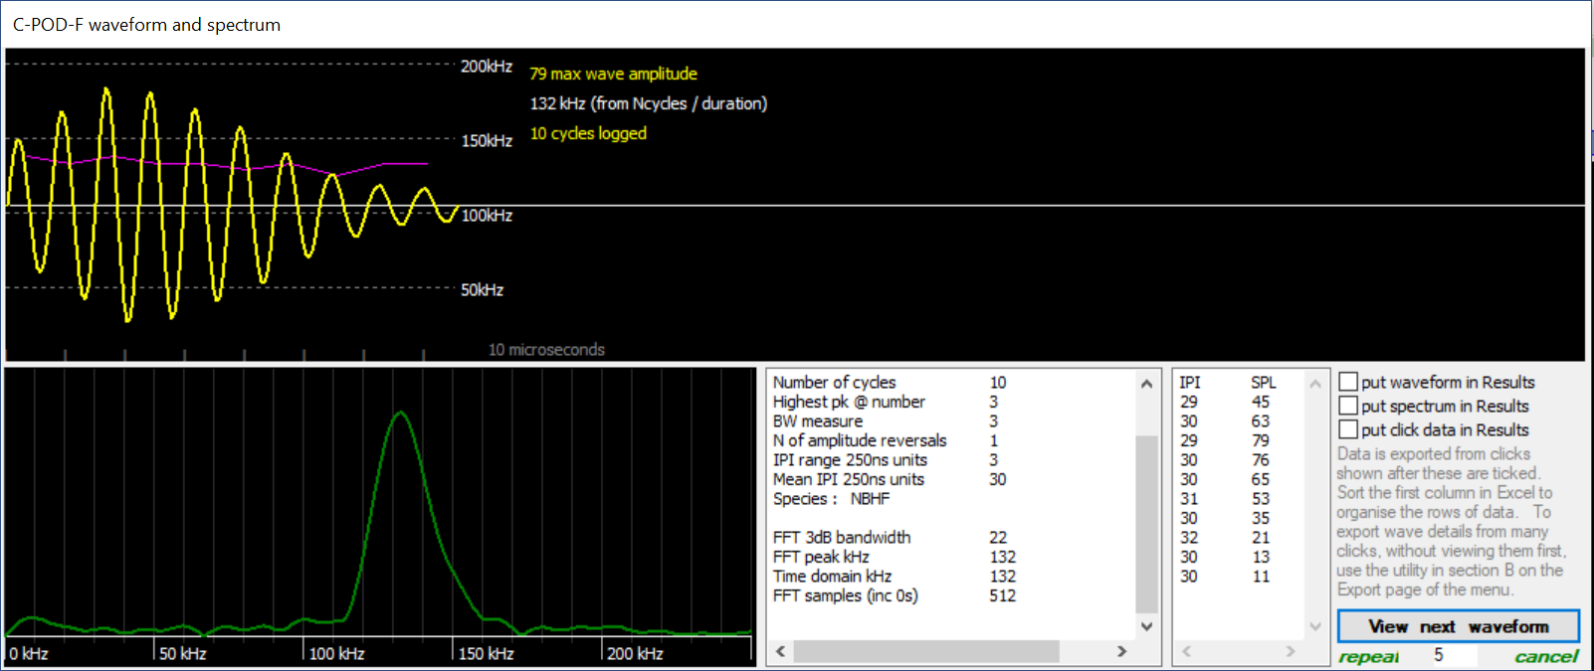
The data stored was the amplitude and timing (to 250ns resolution) of the peak of each wave shown. The waveform, in yellow, has been constructed by fitting sine waves to the 10 points stored. This synthetic waveform has been sampled at 1m samples per second to provide the input data for the Fast Fourier Transform (FFT) that gives us the frequency spectrum, shown in green. The data has been expanded to 512 samples by zero-padding at each end.
The pink line shows the cycle-by-cycle frequency, which, in this case, shows a shallow downward trend. Actually it seems that this is common feature of porpoise clicks, which has previously been overlooked because the FFT spectrum gives no information about the sequence of frequencies within a sound. (The FFT does give phase information on each frequency but this is usually discarded because it is sensitive to the exact positioning of the input data set in the stream of values. Move a few samples earlier or later and the phase values jump around horribly so few analysts have found this information useful.)
The text boxes give largely self-explanatory information. It is notable that, for NBHF clicks, the time domain frequency estimation, which uses the length of the click and the number of cycles within it, gives the same frequency as the peak of the FFT frequency spectrum. The bandwidth (BW) measure here is an arbitrary construct but is more powerful than a conventional bandwidth measurement in its role in the classifiers used in the train detection process.
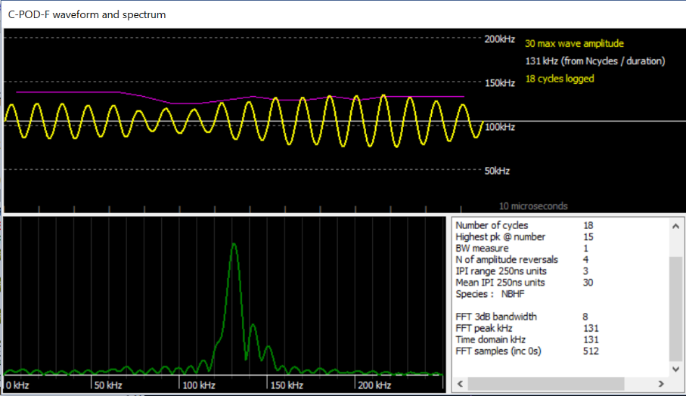

Menu
The ’menu’ pages are shown by clicking on the large green text label, top right, or moving the mouse pointer to the top of the screen and down again, or clicking the tiny ‘menu’ button top left.
The hints shown in red in the green bar at the top explain most of the items when you hover over them, so this just picks out some other points from each page.

Read SD page ~~~~~~~~~~~~~~~~~~~~~~~~~~~~~
1: Location: it is really important to give locations consistent unique names.
If your F-POD is ‘acoustic release ready’ it may generate text files with a name ‘SendTo Chelonia…’ Please do send them as we can then assess the risk of your acoustic release firing accidentally and tune it appropriately.

Files page ~~~~~~~~~~~~~~~~~~~~~~~~~~~~~
Tip: Get used to looking at whatever mixture of FP1, FP3, filters and display parameters helps you see what you want to see.
This is very useful – it provides a quick way to open whatever set of files you need to see the parameters you are interested in:
These buttons allow you to open sets of files, or even 6 different FP3 files so that you can then use the graphs function to compare them in various details – diel patterns, frequencies etc:

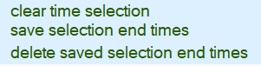
these refer to selections that you set via the right-click pop-up menu when viewing a file. The enable you to analyse parts of a file or create a cropped copy of it.

Filters +files page ~~~~~~~~~~~~~~~~~~~~~~~~~~~~~
Tip: List file times etc. is very useful in any project!
Tip: Use the Delete file set button to delete files – it gets rid of associated map files as well as the FP1 and FP3
All the text here has explanatory hints.
The filters are additive – to be shown a click or train must pass all the filters set, unless ‘ignore all filters’ is in force.
This section allows you to list all the settings of a batch of files to quickly check the uniformity of your project data collection:
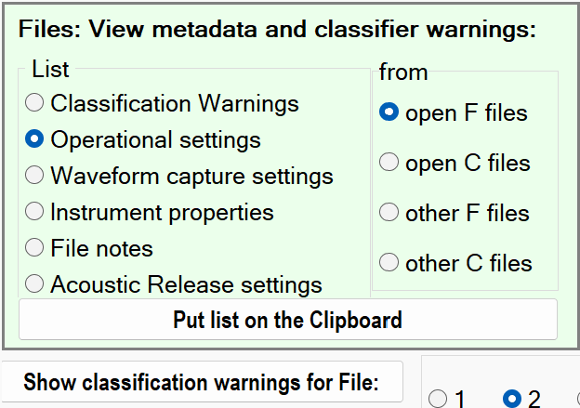
Classification warnings are now – in version 2 – valuable and you should look at them.
Set validation sampling points: The document ‘Validation of F-POD data’ explains this.

Display page ~~~~~~~~~~~~~~~~~~~~~~~~~~~~~
Tip: changing the display time width can be helpful.
The hints shown in red in the green bar at the top, e.g. explain the software item under the mouse pointer.

Several options here are provided to optimise displays for screengrabs to be used in documents. Ctrl G creates an automated screengrab of the data display area, with a white background.
Display line width: thicker lines can be useful when sharing screens.
Colour clicks by train number: in hi-res click amplitude displays clicks are normally coloured by their frequency. This option makes it easier to disentangle overlapping trains.
Show fast click rates/10 as a blue line: just to enable you to get a quick idea if the train is what you are looking for.
Put graph … in results: For studies with many files exporting data to a database and analysing it there can be much faster.
Array viewer This can show an animation of detections made in a grid of loggers … more details needed here. Contact us if you want to use this.
Times In the FPOD app times are stored as the number of minutes since the start of 1900 (as calculated wrongly by Microsoft … so it disagrees with the correct value in R! by 1 or 2 days). This gives you access to those minute numbers.
File viewer Show block n of any file: this just lists the values in blocks of 512 bytes from any file. Can quickly show that a file is mainly blank/empty.
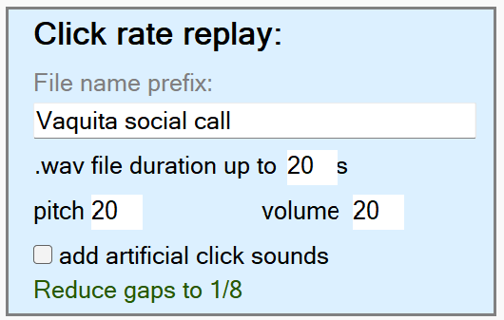
This generates an audio file in WAVE format (filename.wav) in which the changing click rates on show are faithfully represented as changing tones. It’s particularly interesting for social communications. You will need to try adjusting the pitch and duration to get a result that is meaningful to us.

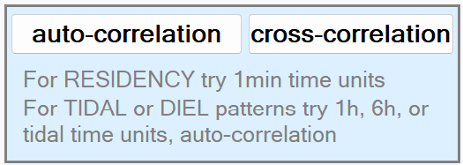
Auto-correlation is useful for assessing the residency time of cetaceans, and for determining whether cyclic patterns are tide to days or tides.
Cross-correlation is useful for study movement between sites.
GRAPHS
The Graph button at the top of the screen graphs only the data displayed, and shows whatever you set here. By contrast the Analysis page includes the whole time range available, and has no graph options.
The available graphs here are these : * = most often used
kHz*
Clicks/s (PRF)*
Duration (N of cycles)
SPL (sound pressure level)
Wavenumber of peak (Pk@)
Bandwidth
Terminal kHz
Cluster size
kHz profile
NBHF index*
Diel: N of clicks*
Diel: kHz*
Diel: Train clicks/s*
Diel: Duration (N of cycles)
Diel: SPL (sound pressure level)
Diel: Av Train Duration
N of clicks in Train
KHZ.IPI prior
KHZ.IPI minus1
KHZ.IPI pk
KHZ.IPI plus1
KHZ.IPI plus2
IPItrends
auto-correlation PRF
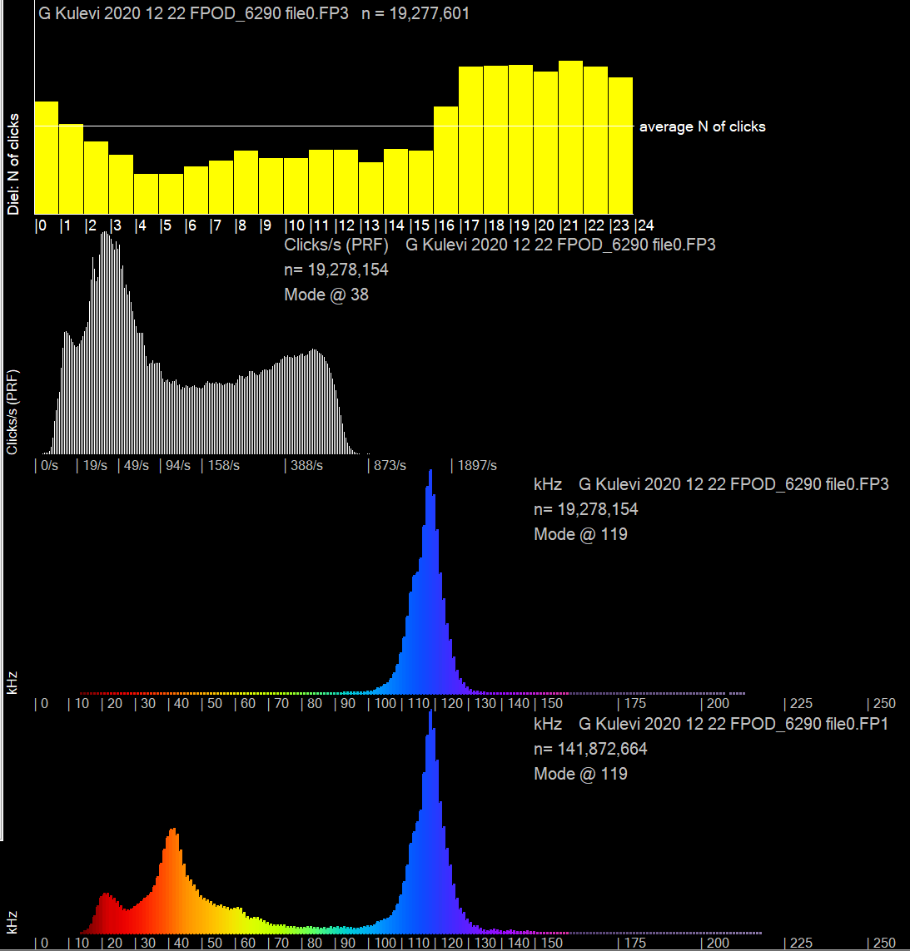
The option to omit C/FP1 files (shortcut Shift F11) is provided to save time when the results from these files are not interesting.
Here’s data from the coast of Georgia in the Black Sea, filtered to show Harbour Porpoises:

n = 19million = number of clicks in NBHF trains displayed

in the Clicks/s graph the horizontal, X, axis is on a log scale.

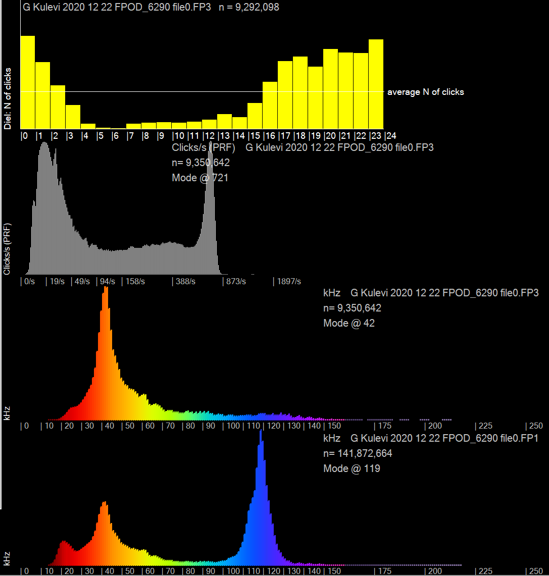
Here the data has been filtered to show ‘other cet’ i.e. dolphin species only.
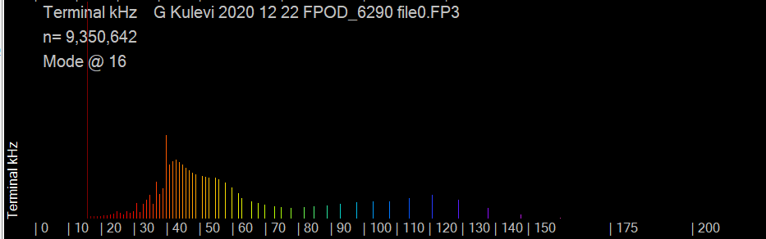
Terminal kHz is the frequency of the last cycle in the click, and is a less precise (more compressed) metric, especially at high frequencies, resulting in graphs like this.

… could be useful for beaked whales.

Trains page ~~~~~~~~~~~~~~~~~~~~~~~~~~~~~
Tip: bring the warnings version of your files up to date … see below
While KERNO-F is in progress you see a display like this. If there are no detections it stays black but the minutes analysed, top left, shows it is still working.
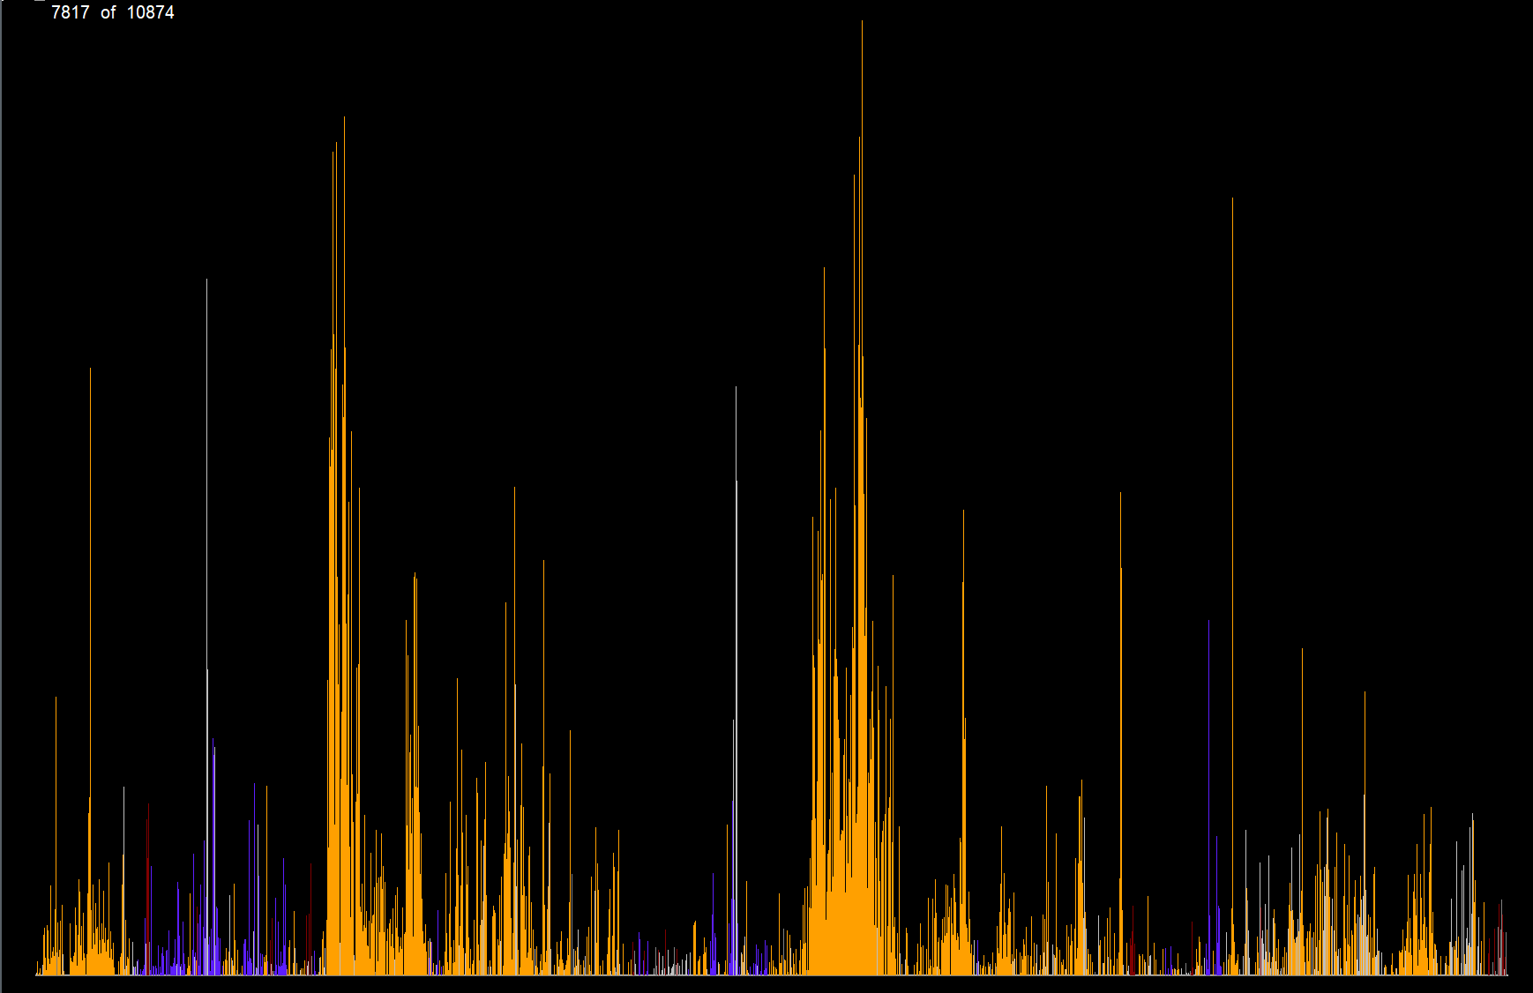
Normally you just click ‘Detect click trains in FP1 files -runs KERNO-F classifier’ and let your digital slave do billions of calculations for you. A separate document on special cases, like analysing pinger studies, will be provided …
Generate Version 2 file warnings: This updates the file warnings – this version gives really useful warnings that can be viewed via the Filters +files page.
Export Fish tag data: PODs do store fish tag data that can be used to identify the tag number but this process is not yet in a usable form.
Show third party access form: third parties may be able to develop classifiers for species discrimination in specific locations or data sets, and this provides the interface for that. A rich set of features will be exportable and the results of your classification can be injected back into the FP3 file to give access to all the visualization, filtering and exporting.

Settings page ~~~~~~~~~~~~~~~~~~~~~~~~~~~~~
Settings are sent to the F-POD on the SD card in small text files ‘F_SETS.txt’ that are generated on this page of the menu.
Having read the settings file the POD will retain those values indefinitely until it finds another settings file on an SD card that is inserted. It is a good idea to remove the SD card and delete its settings files after it has been inserted, and this is essential for the time setting file.
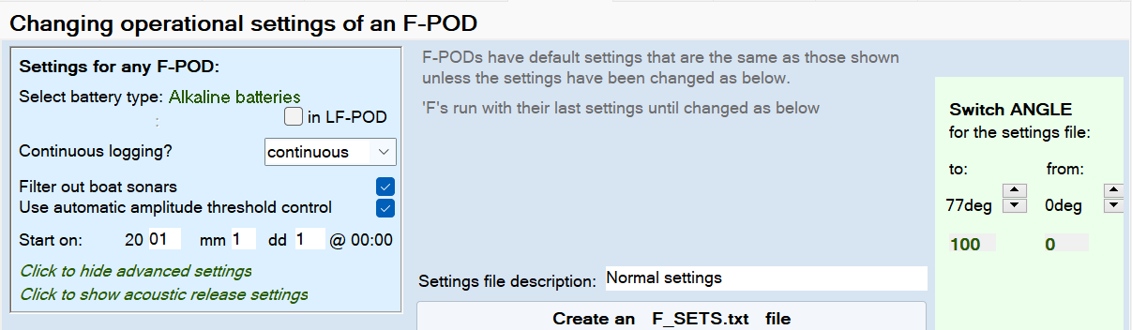

Select battery type: click the label to go through the options. This sets a minimum voltage for a stack of batteries, at which the POD will shift to the next stack on its list. The list starts with the weakest usable stack, so weak batteries are exhausted first in order to minimise discarding of part-used batteries.
Currently the POD housing has two battery stacks. The LF-POD has only one, so it can run them down lower until it fails.
You can override the defaults in the advanced settings by selecting ‘user set switch voltage’ and setting a new value in the ‘Battery min voltage’ box in advanced settings. The units here are 0.1V
Continuous logging?: Intermittent logging can be used to extend the running time. Power consumption in OFF minutes is low but the temperature and angle are still logged.
Filter out boat sonars: This activates an algorithm that runs in each minute and tries to detect up to two different boat sonars from the similarity of the IPIs around the peaks of successive clicks. If found, then a small range of click frequencies is excluded for the rest of that minute. The frequency rage 117-160 kHz is excluded so that the sonar filter will never exclude NBHF clicks, but relatively few sonars are in that range – the commonest frequencies are 50, 80, 100 and 200 kHz sonars. If one of two sonars are found this is recorded in the data and in high resolution displays of click frequency the time and frequency range of the exclusion band activated are shown as a dark grey box.
The value of this filter is that it greatly reduces the risk of boat sonars ‘jamming’ the detection process, forcing the amplitude threshold up, and filling the memory.
Use automatic amplitude threshold control: This raises the minimum amplitude of a click that will be logged if there are a number of successive noisy minutes and lowers it after some quieter minutes. These threshold levels are shown by a green line on low resolution displays and can be exported. You might wish to disable this for short specialised studies with high limits on numbers of clicks logged, but it is a good idea to normally have it in use as it removes the ‘maxing out’ problem of C-PODs with its knock-on effect of impaired train detection.
Start on: this allows you to delay the start to some date. You could use this to ‘daisy-chain’ multiple PODs in a remote location to obtain full coverage of one or more years.
Click to show advanced settings:
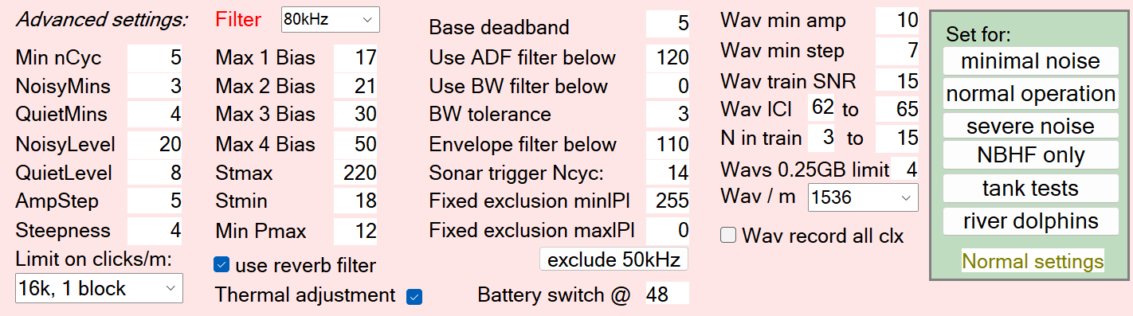
The basic advice here is: Don’t change any of these! The defaults are included in the F_SETS file. Some pre-set options are included:
‘tank tests’ cancels various filters that aim to exclude weak broadband noise, the threshold adaptation, the sonar filters, input analogue filters and the angle switching. Your tank tests may still give misleading predictions of performance at sea for several reasons, e.g. generating a 130 kHz click with a square envelope and 8 cycles may be translated by the behaviour of the signal generating system into a click with the loudest cycle at the start. That would be correctly rejected by the KERNO-F classifier as not being an NBHF click, although the spectrum of such a click would probably pass FFT tests of spectrum frequency and bandwidth of an NBHF click.
‘severe noise’ is suitable for rough shallow water, or high levels of shrimp noise. Ideally you should compare two F-PODs with different settings in such locations, but this requires cetaceans to be common.
‘river dolphins’ aims to reduce the impact of noise from moving sand. It is not needed in muddy rivers.
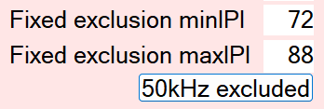
Where 50kHz filters are very prevalent clicking the ‘exclude 50kHz’ button gives these settings which remove the need for the sonar to detector to find the sonar in each minute. The sonar detector is then able to find and exclude up to two other sonar frequency bands. You can set any pre-excluded band of this sort using the ‘fixed exclusion’ settings. These are defined as inter-peak-intervals = wavelength in 250ns units = 4000 /your target frequency. Allow plus and minus 10% of the frequency for the min and max.
Other controls:
Wav record all clicks: overrides the normal process in which likely cetacean clicks, assessed by being in what looks like a train, are the only ones that have full waveforms stored. This does not affect detection performance but the volume of data will increase substantially so it is only suitable for short deployments.
The other controls are best left alone because it is easy to end up with files recorded with different settings and then you need to know how much this may have affected the results, and that can only be determined empirically in sea trials. Most of the controls have ‘hints’ visible at the top of the screen.
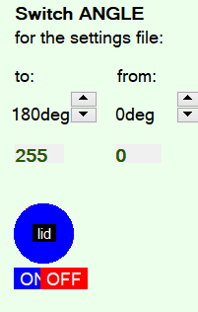
Many sea trials were run to arrive at the default settings. Do not follow advice in any published paper to vary these settings without consulting Chelonia first, as inappropriate variations in C-POD settings or classifiers have been proposed in published papers. These have been proposed on the basis of obtaining improved detection rates in samples of data that are far too small to give good ‘generalization performance’ and the consequent errors can be large.
Switch angle:
This is used to allow you to start an F-POD many days before deployment and keep it horizontal and asleep so that it uses little power until it is deployed. If there will be no long delay then do not use this but force the POD to be ON at all angles. This is because angle settings can lead to data loss if it is deployed at an OFF angle or gets into one by mistake e.g. on a rig that falls on its side etc. Deep F-PODs or F-PODs for beaked whale monitoring may be deployed ‘upside down’. The angle options do allow this but should be tested to ensure they are working correctly before committing the POD to the deep.
The diagram represents a POD with its lid at the centre and its transducer housing at the outside.

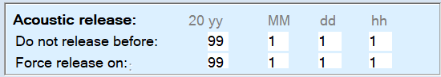
Acoustic Release
… is not yet available. It screws on in place of the standard lid and allows a restraining line to be set free when a POD- specific acoustic code is received from a deck unit. It relies on the continuing activity of the POD itself, so it has a ‘Force release on …’ date. A GPS to phone system tracking system is planned to allow recovery after such an event. It also has a power saving ‘Do not release before’ option.

RESET the F-POD CLOCK
The clock is set to GMT = UTC. You can reset it to your local time. Follow the instructions on the Settings page. An error of less than 100ms is easily achieved. Accurate setting is particularly valuable if you wish to compare data from different PODs in detail as events will then be visible on the same high resolution screen.

Navigation page ~~~~~~~~~~~~~~~~~~~~~~~~~~~~~
You can use these scaling factors to give each data panel graph exactly the range you need – most often F5 and F6 get you near by doubling or halving the current scale. The factors here give more precision if you need it. The counts value also scales the height of the black line in FP1 displays that shows the number of clicks logged.

About page ~~~~~~~~~~~~~~~~~~~~~~~~~~~~~
Delphi source code and coding notes: This gives the code used to unpack the raw data from the FP1 in this actual version of the software, plus notes on program.

Export page ~~~~~~~~~~~~~~~~~~~~~~~~~~~~~
Tip: the ‘search directories’ function is very useful
All items have info shown in red in the green bar at the top.
Detections and Environment: This adds information to each logging period about the angle, logging threshold, and some measures of the soundscape.
Export data for third party species analysis: not implemented yet, but please let us know if you want this and it will be done…! Species classification is a ‘clustering’ type of problem and well suited to various machine learning methods, while the train identification is a different type of signal processing problem for which few existing machine learning methods are useful. So the plan is to export the KERNO-F output for more detailed species discrimination.
This will include a simple interface to allow third party classifications to be written back into the FP3 file so that all the display, analysis, filtering and exporting functions are available on this new classification. The names for new and different classification groups can also be incorporated and used by the FPOD software.

Results page ~~~~~~~~~~~~~~~~~~~~~~~~~~~~~
Add sightings to files: This is a powerful tool. You can, for example, find filters that identify the presence of sounds from a pinger or sonar, and use that to identify those minutes in an exported list of minutes; then format that as in the template spreadsheet ‘FPOD sightings entry.xls’; paste the relevant columns into the Results page and read them into the file. Then you can filter minutes by the presence or absence of this feature. Or the list might be of species sightings.

Analysis page ~~~~~~~~~~~~~~~~~~~~~~~~~~~~~
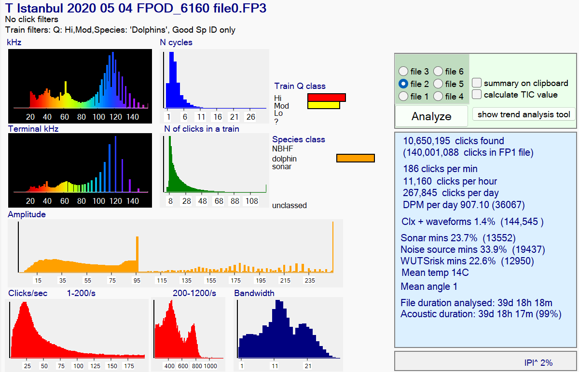
If an FP1 file is analysed the last entry in the results list is how long it would take to fill a 32GB SD card at the rate found.
The Clicks/sec graph is split to show the range above 200/s upscaled by x10 as otherwise interesting variation here is lost.
The frequency graphs have a gappy appearance at high frequencies due to the resolution at which this data has been stored.
The IPI^ value is the proportion of clicks in which the sum of the two wavelengths before the loudest cycle re shorter than or equal to the next two. This is typical of NBHF clicks.
The TIC value is the ‘train interval clustering index’ – a measure that is higher for cetaceans than random events or noise.
Amplitude graphs can have a saw-tooth profile due to the effect of the time-domain filters that exclude shorter clicks of higher bandwidth in a series of steps. These filters, plus the very compact mode of data storage enable the F-POD to run for long periods and provide ‘high value’ data as inputs to a powerful train detection process that uses the time domain features of clicks.

The Trend Analysis Tool
The tool determines trends in the detection rates from PODs at one or more fixed sites.
It uses ‘Paired Year Ratio Assessment’ = PYRA.
This method is described in ‘Estimating cetacean population trends from static acoustic monitoring data using Paired Year Ratio Assessment (PYRA)’ Grist et al https://journals.plos.org/plosone/article?id=10.1371/journal.pone.0264289)
The distinctive advantage of PYRA is that it avoids the need for estimation of both seasonal and diel patterns. Cetaceans often show big seasonal and diel patterns of activity and their estimation from gappy data is a major source of error in some other methods.

How it works:
Paired Year Ratio Assessment requires 2 or more years of data and handles gaps in the data by using only data from days that can be ‘paired’ or ‘matched’ with data from the same day in the following year. So the sum total of the detection metric in the second year is divided by the matching total in the first year to give a ratio that represents the growth or shrinkage – the ‘change value’ - of the data logged.
This two-year data window is moved forward one day at a time to produce a change value for each date. The date for this change value is the date between the two years. If the data window is moved further the number of matched days eventually falls as the second year becomes more incomplete. When the volume of detections becomes very low the change value becomes more and more wild! That’s also true at any time within the body of the data when there are few detections, so to avoid wild results a small ‘ballast’ is added to both years. This has the effect of pushing the change value towards 1.0 = no growth.
The process ends when there is no longer any paired data in the Y2 period. It can also start when there is only 1 paired day, but these ‘thin ends’ are of little value. So change values based on less than a mean of 1 DPM (detection positive minute) per day are not graphed … but all paired data is used in the assessment of overall trends.
A measure of uncertainty is obtained by random resampling of whole days, with replacement, within a 21-day window centred on the paired day.

What does it tell us?
Sampling the trend in cetacean activity at a number of sites is often a very much cheaper way of getting a handle on what is happening to the population of a cetacean than doing repeated line transect surveys of its entire distribution from boats, planes or drones. Much larger numbers of detections can be made within the lower cost, and they give much greater precision. So what’s not to like?
The sites chosen will usually cover only a small part of the distribution of the species (the monitoring of the Vaquita is a notable exception). So redistribution of the animals is potentially a major issue. Has the species declined or has it moved away? Has it increased or become more concentrated in the area logged? Habitat type will often be a factor in redistribution, and analysis of trends at logging sites with differing characteristics may be relevant (the app allows you to select and view subsets of the sites and to export data from all sites individually). These questions need to be considered and related to other biological or physical data, so that these trend results form a part of that larger picture.
The bottom line is: the trend values are simply the trend seen in the set of sites, and their predictive value for the ‘local population’ and the whole population needs to be determined using other data which might include prior data from such trend monitoring elsewhere, data on fish stock changes, physical oceanographic data, etc.
Limitations
Gappy data: when logged periods don’t align across years the un-paired days are not used. A lot of data can be ‘lost’ this way, so if the whole year cannot be logged it’s good to log the same parts of successive years.
Site stability: sites should be fixed, and any change in position of more than 200m should be treated as a new site. This is because we know that detection rates of porpoises vary significantly at this scale, even when the habitat looks superficially fairly uniform. (A fully randomised spatial design is theoretically possible and would use only the overall statistics for each year but would require many more sites).
If a site changes – perhaps construction works starts nearby, or it is a maturing aquaculture site – then a local trend may be due to those changes, so it should be excluded from the overall trend analysis, but its own trend may still be of real interest.
Grist et al. (2022) discuss the limitations of PYRA.

Steps in using the trend analysis tool
In brief:
- Give your data files site codes that identify each site correctly. If they have no site code the early part of the file name can be used and must uniquely identify each site in the study.
- Crop all files to remove any time not in the water.
- List all file times, (see ‘Filers +files’ page) then sort by dates of start and end to identify the dates that should be used in the trend analysis.
- Enter the earliest and lates days ,of any file, in section 1 and also any exclusion period if part of each year was not normally logged or was subject to something that might interfere with the normal distribution of the cetaceans:
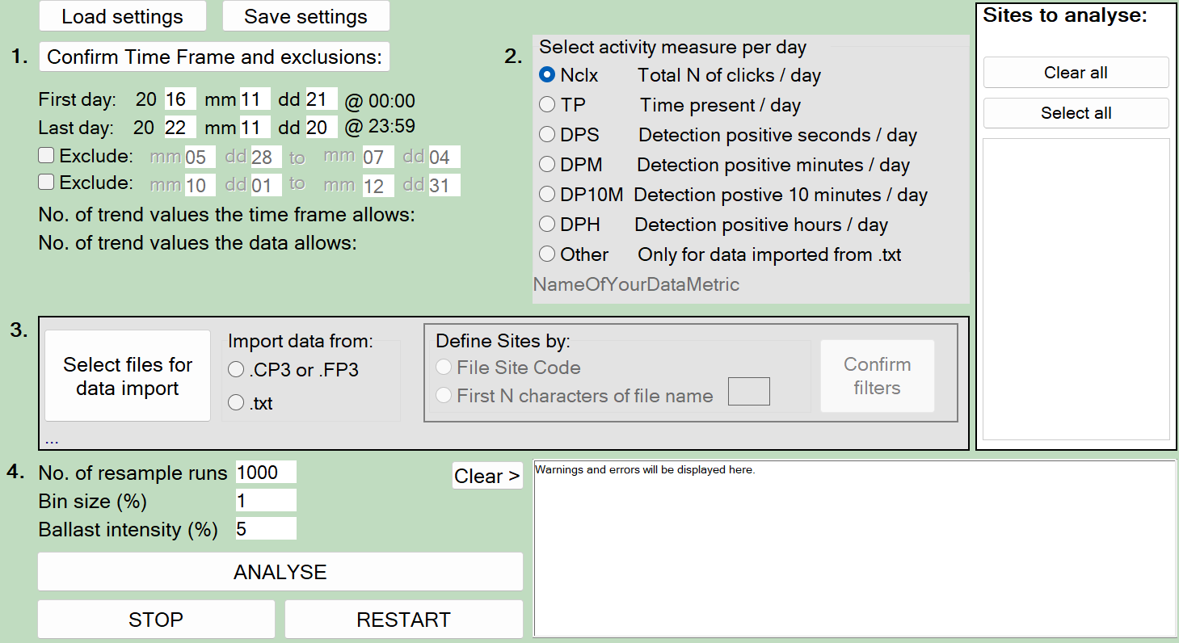
- Select a detection metric. DPM – detection positive minutes is the default. Larger units may ‘saturate’ and it’s a good idea to use only units that do not go above about 30% of the maximum value they can have in the (which is 24 for DPH, 144 for DP10M, 1440 for DPM etc.) in the present data set or in the likely future of the project. Nclx may be conflate presence with feeding or social activity.
- Click ‘Confirm Time Frame and exclusions’
- Set the filters for the input data e.g. Hi and Mod Quality, NBHF species, High species confidence. You could do assessments where you filtered out fast trains or slow trains etc. if you wished. If you are reading the data from a text file the filters will be those in force when the data was originally read.
- In section 3 select where you will import data from.
- Select ‘Define sites by’ unless you are reading from a text file.
- Click Confirm filters.
- Click ‘Select files for data import’. The number of files and sites found will be shown. Later you can export a text file of the data and read that if you wish to save time.
- Generally keep defaults for the resample runs, bin size and ballast …. more in Notes below.
- Click ‘save settings’ at the top of the form and give it your project name.
- Click Analyse. File reading and processing are followed by a ‘View graphs…’ popup message.
- Now it gets interesting! But before you get into viewing the data click ‘Put site list on clipboard’. The list will be on the clipboard so you can paste it directly into a spreadsheet and check that your files are correctly grouped into sites. If any have the wrong site code that can be changed via the File changes section on the Filters +files page – and you’ll need to repeat the process above. If section 5 has disappeared, click ‘Show PYRA controls’

Notes
The resample runs sets the number of times each paired day will be resampled – see ‘How it works’ above. If you set the resample runs to 1 there is actually no resampling - your original data is used. Increasing the number of resampling runs give a smoother distribution of change values. Larger numbers are a good idea.
Bin size: Each resampled PYRA change value will be added into a bin to produce percentile ranges and a histogram of results. The size of each bin can be set using the bin size value. Change values beyond the value of the most extreme bins will be added to that bin.
Ballast intensity
This is explained in ‘How it works’ above. The default is to add a ballast that is 5% of the overall sum of detections to both the year before and the year after the time point for the change value. It’s effect on the overall trend is very small, but it heavily damps values where very few detections are present, pushing the change value towards no change.

Data collected

The F-POD data on the SD card consists of a header that includes information about the POD, its settings, and the time of the start. On the PC all that data is retained, and there is more space in the header for other information, including the user entries on the Read SD page.
The main body of the data consists of minute timestamps, click records, and waveform records. Each takes up 16 bytes. The click record structure is (IPIs = inter-peak-interval in 250nanosecond units; amp = peak amplitude of a cycle) :
Byte number | Click record
0 | time in 5us within minute, MSB (most significant byte, max value = 183) of loudest cycle.
1 | time in 5 microsecond units
2 | time in 5 microsecond units, LSB (least significant byte)
3 | N of cycles in click. max=255
4 | Pk@ 4bits; IPI range within click 4 bits (Pk@ is the wave number of the loudest wave)
5 | IPIpreMax
6 | IPI Max
7 | IPI post1
8 | IPI post2
9 | amp of cycle before peak amp
10 | amp of peak (=Pmax)
11 | amp of cycle after peak (P+1)
12 | IPI before first cycle
13 | Duration, most significant 4bits : AmpReversalCount (in lower nibble)
14 | Duration, least significant byte
15 | IPI of last Cycle
The amplitudes are in a compressed 8 bit format. Clipped waves have their rise time, from zero-crossing to clipping stored and this is extrapolated to the true peak. For heavily clipped low frequencies this goes up to 12,800. The whole scheme can be exported via the Exports page.
The code for reading each 16 byte record can be accessed via the ‘About’ page of the menu of the FPOD app.

These data give a rich time domain description of each click that is used to give high discriminatory power to the train detection process.
Some clicks have up to 21 cycles of ‘raw data’ that is intended to provide more detail for various purposes. It consists of a value of 250 as a record type identifier, followed by a series of pairs of values giving the amplitude and period of 7 successive waves.
Minute timestamps carry information on temperature, the angle of the POD, the level of the threshold setting, the voltage of the battery stacks and which is in use.
Warning: POD dates
These give the same value as you get in Microsoft’s Excel, Access etc, but:
These are based on the number of days since the start of 1900 and give a different value in ’R’ which gives a 1 or 2 day difference. ‘R’ is correct!
Thanks to Leah Crowe for identifying this problem.

Topic Notes and glossary

Absorption | Sound is absorbed during its passage through seawater at a rate that is higher for higher frequencies of sound. The characteristics of broadband clicks consequently changes during transmission with the higher frequencies being reduced more than the lower frequencies. This difference increases with the distance from the source.
ADCP | Acoustic Doppler current profiler. These typically operate at1Mhz or higher but often produce lower frequencies that may affect the distribution of cetaceans and be detected by C-PODs.
Amplitude | The height of the pressure wave of a sound. Also expressed as SPL = sound pressure level. This is used here as a simple instantaneous pressure scale value, but in some systems, it refers to a value in decibels of the RMS value of the pressures of the whole wave.
amplitude profile | The sequence of heights of the waves in a click. All clicks have three amplitudes logged – the loudest and the one before and after. Clicks with full waveform data have more.  The amp profile of NBHF clicks and boat sonars is fairly flat. That of dolphin clicks and many non-cetacean sources is much further from flat.
AmpReversalCount | This is the number of times the cycle amplitude trend (whether a wave peak is higher or lower than the one before) within a click switches from rising to falling. It is assumed to be rising at the start.  It is lower in cetacean clicks than noise and lowest in NBHF clicks.
Bandwidth | A measurement of the frequency width of the FFT spectrum. The width at half the maximum is often used = the 3dB bandwidth. Concatenation of reflections of a click, or of refracted replicates will make the click longer and this reduces the bandwidth.  The F-POD exploits a different approach to bandwidth by logging a high precision measure of the variation in length of the waves around the loudest wave in the click. These values are least affected by ambient noise and are independent of the length of the click.
BBT | Broad band transients. Dolphins that whistle make short clicks. All short clicks have a Fourier spectrum with a broad bandwidth, so ‘broad band’ is predicated by ‘transient’. NBHF clicks are longer. Longer clicks could be broadband or narrowband.
Beam structure | Clicks are emitted from the cetaceans’ melon as a narrow beam of sound that is loudest near the center. In dolphins the mix of frequencies changes strongly across the beam, with low frequencies dominating the outer edges of the beam, and vice-versa. This can often be seen in POD data, with surface echoes revealing the frequency content of a different part of the beam from that forming the direct path to the POD. For NBHF clicks there is little change in frequency content across the beam.
Bedload | See sediment transport
click | See event. Click is normally taken to imply a short episode of increased amplitude. Whistles, by contrast, are not short and are not heard as a click but as a tone that may sweep up and down in pitch.
Click rate | The number of clicks per second. Also called PRF – pulse repetition frequency. It is the reciprocal of inter-click-interval.
clipping | The pressure of a loud clicks may reach the maximum output level of an amplifier or ADC (analogue to digital converter) before it has reached the peak of that cycle. It is then ‘clipped’. The time taken between crossing zero and clipping can be used to extrapolate the peak value.
clusters | See multipath
coherence | See train coherence
crop | Make a new shorter file that is a copy of part of a file with time removed from one or both ends.
cycle | One wave of sound pressure going from zero up, then down below zero then back up to zero.
Date format | MinuteN refers to the minute number in FPOD time – it is the number of minutes since the start of the year 1900. Divide this by 1440 to get the time used in Excel and Access, which is a floating point number representing the number of days and fraction of the last day since the same start date.
dB | Decibels are intended to represent intensity (= power) of a sound and is 10 times the log to base 10 of the ratio of rms values. It is a long out-dated unit that is rightly deprecated by the SI system of units. It is not a physically precise unit of comparison because that depends on the acoustic impedance of the media being identical, it is troublesome to learn and it contributes to errors!  The alternative is to report pressures directly as Pascals or rms pressures.
Detections and Environment | This adds information to each logging period about the angle, deadband, time lost (to ‘maxing out’ = reaching the limit for the minute) and some measures of the soundscape.
Doubtful | See Q class
DP10M | Detection Positive Ten Minute periods. These are 10minutes set by the clock, so their boundaries always correspond with the hour ends. This unit reduces the effect of variations between loggers but will saturate (reach the maximum possible) before DPM if the density of animals is high.
DPM | Detection Positive Minutes. This is a good general purpose measure of the level of acoustic activity. It’s not the best for every purpose and more information is on the website.
dur / duration | Duration of clicks in FPOD data is often represented as the number of cycles in a click. The duration in 250 nanosecond unit is also stored and used to calculate the frequency of the click.
EDR | Effective detection radius. This is the radius of a circle that would contain as many animals as were detected in total i.e. the number missed inside this radius is the same as the number detected outside it. There should be a time period specified i.e. ‘the 1 minute EDR’ as it will vary with this time period.  It is not the same as the mean distance at detection, which is typically much larger.
effective detection radius | See EDR
elephant outside the room | See the discussion of Notes and Warnings
envelope | An imaginary line stretched over the amplitude peaks of the waves in a click.
error estimation | See Warnings
event | ‘Clicks’ are detected by PODs as short periods in which successive wavelengths are similar. These are tonal ‘events’, and there is no requirement that they must be louder than the sound stream before or after, although they usually are.
Export SPL as Pa | Ticking this box will show the amplitude of each click in Pascals by correcting for the frequency-dependent sensitively of the system and the non-linearity of the amplitude scale. However, it makes it less clear when a frequency has reached and may have exceeded the maximum response for that frequency.
False negative | Clicks made by cetaceans that were missed by the detector. Because it includes clicks from cetaceans at all distances from the detector the idea is better represented by the ‘detection function’ that describes the proportion of false negatives in relation to the distance from the detector.
False positive | Clicks identified as a coming from a cetacean that did not. In the case of trains the concept is a bit different as the inclusion of a single click that did come from a cetacean means that it correctly represent the presence of a cetacean.
FFT | Fast Fourier Transform. This takes in a set of amplitudes, measured at uniform intervals, and generates half as many complex numbers. One of the pair of values in each complex number represents the intensity of one frequency within the set of amplitudes. The set typically has 256, or 512, or 1024 (or other power of 2) values.
Fish tag | See VEMCO fish tag
Frequency domain | The information within the frequency spectrum. This includes no information on the order in which frequencies appear in a sound.
frequency profile | The F-POD stores the wavelengths of the successive waves in a click. These give information about the frequencies in the click and their time sequence, and can be graphically displayed as the frequency that would have that wavelength in a pure sine wave. Frequency profiles cohere in trains.  As with the amplitude profile it is flatter in clicks from NBHF sources and boat sonars than cetaceans and noise sources.
generalization performance | The success of a classifier when applied to data that was not part of its training set.  Some papers have based advice on better POD settings on limited studies providing a training set only. This is risky, at best, predictably bad at worst.
guard band | A simple technique of detecting a narrow band signal is to compare the frequency of interest with a ‘guard band’ of higher or lower frequencies. The very first POD used 3 guard bands with used defined threshold ratios for each.
Hi, Mod, Lo, Doubtful | See Q class
hints | See the text in the green bar at the top of the FPOD app screen for hints on the function of whatever is under the mouse pointer.
ICI | Inter-click-interval. The time between the starts of successive clicks in a train. For cetacean click trains this ranges between 1 or a few seconds and less than 1ms
Include headers | Don’t include them if you are exporting from multiple files to go into a database or spreadsheet.
IPI | Inter-peak-interval. The time interval between the peaks of the waves in a click. In the F-POD this is measured in 250ns units.
KERNO | Chelonia’s automated classifier for data from C-PODs.
KERNO-F | Chelonia’s automated classifier for data from the F-POD.
kHz | 1000 cycles per second. Human hearing in children goes up to 20kHz which is the upper limit of the audio range, with higher frequencies being called ultrasound.
landmark sequence | A linear trend of falling inter-click-intervals that may be seen when porpoises approach an acoustic landmark from 250m or more away.
Lo | See Q class
MaxPk | The SPL of the loudest cycle in a click
Mod | See Q class
multipath | Loud clicks are reflected structures within the cetacean and then, perhaps repeatedly, by the sea surface, the seabed, and possibly other structures. The sound beam is also bent this way and that by differences in sound velocity created by differences in salinity, temperature and pressure. These refract the beam and create a heterogeneous wave front, so hydrophones at different positions do not receive identical signals even if the beam was originally uniform in cross section, which it isn’t. The surprising thing is that these pathway effects change over remarkably short time periods.  The multipath cluster to some extent reflects the whole cross-section of the beam so it has a wide spread of frequencies when the source is a BBT click and a narrow spread when the source is an NBHF click.  The coherence of cluster characteristics is useful in train evaluation.
nAll | The number of all clicks in one minute in a CP1 or FP1 file.
NBHF | Narrow band high frequency clicks are made by porpoises and a few dolphin species. They are usually around 130kHz and relatively long – 8 to 12 cycles with a typical amplitude envelope. The species that make NBHF clicks do not whistle.
NBHF index = NBHFi | A numerical index, used in POD software, of the resemblance of a click to a typical NBHF click. This is derived for each click in the CP1 or FP1 file but is much more powerful (i.e. discriminatory) in FP1 files because they include the successive wavelengths and amplitudes around the loudest cycle of the click. Clicks ‘source code ...’ on the About page for full source code for this classifier.
Ncyc – number of cycles | The number of cycles in a click. Typical mean of NBHF clicks = 8, and is much lower for BBT clicks from dolphins.
Noise levels | F-POD data is not suitable for measurement of noise levels. This needs a broadband WAVE file recorder with an appropriate frequency range and anti-aliasing filtering.
Pamguard | A widely used open source app for the analysis of wav file data to detect, classify and localise cetaceans.
Pascal Pa | The basic unit of pressure: 1 Pa is 1 Newton / sq. m. Hydrophones are pressure sensors that give a voltage that is proportional to the pressure. The weakest porpoise clicks detected by the POD have a peak pressure of around 1Pa.
PeakAt Pk@ | The number of the cycle in a click that has the highest amplitude. Typically 1 for dolphin clicks and 4 or more for NBHF clicks, and very variable for boat sonar pulses.
Phase | Two waves are ‘in phase’ if their peaks, at some point in space, occur at the same time. If they are of equal amplitude but come from slightly different directions, they will at some places be in phase with increased amplitude, and at other places they may cancel out. Such constructive and destructive interference is common and is sometimes easily seen in POD data.
Play sound | The ‘play’ button translates inter-click intervals into tones that rise as the click rate (1/ICI) rises. It uses the amplitude and smooths the transition between ICIs
PriorIPI | The inter-peak-interval before the designated start of the click. In some dolphin clicks it may have been part of the click but not defined as such by the algorithm running in real-time on the POD that tries to define the start and end of clicks.
PYRA | Paired Year Ratio Assessment. This is a simple robust method for estimating trends in multi-year data sets. It is the basis of the trend estimation tool.
Q class | Hi, Mod, Lo, doubtful. These classes try to represent the probability that the train came from a true train source and was not a chance association of similar clicks from different sources. They do not map from C-PODs to F-PODs as in the latter doubtful trains are classified less often and trains identified as trains of echoes are put in this class.
refraction | The bending of sound by unevenness of the medium it is travelling through. Sea water is never uniform in salinity, temperature (and movement and pressure) so a sound does not travel in a perfectly straight line without distortion, but can diverge, converge and interfere constructively or destructively with itself.
replicates | The same click arriving later than the earliest version having travelled along a different path as a result of reflection and/or refraction.
rms | Root mean square. The intensity of a sound is represented by the rms of the successive amplitude values that make up its waveform.
Sediment transport | Seabed material brought into suspension by currents. It generates sediment transport noise. Particles around 0.25mm diameter generate sound around 130kHz. All sandy seabeds move sometimes. If they did not, they would be overlain by mud.
social calls | NBHF species probably all use distinctive patterns of ICI to create social calls. Other species, which includes most dolphins, use whistles as social calls, and also use bursts of clicks at a very high rate.
Sonar filter | See text
Sonar risk | The estimated probability of the presence of a boat sonar in some data, typically 1 minute of data. The detection of a sonar risk may bias the detection of cetacean.
Sound pressure level | Here this is used to refer to instantaneous pressures, e.g. of the peak of a wave or click.
Species class | The primary species classes given by the KERNO classifiers are NBHF, other cet (= BBT = other cetaceans), boat sonars and unclassed.
Spectrum | The distribution of energy across the frequencies in a sound. The FFT
SPL | See Sound pressure level.
Threshold | When the F-POD is running it responds to a series of minutes with high click counts by raising its detection threshold. This is not a simple threshold but is applied first to short clicks and only later to long clicks. The benefit is that large number of weak short clicks are of little value in detecting dolphins, but weak long clicks are more often useful in detecting NBHF species.  This is sometimes referred to as the operational deadband setting. It has several steps. The starting point and criteria for changing up or down are under user control, but most changes will be worse than the default settings!
TIC – time interval clustering | A measure of how clustered detection are in C-POD data.
Time | Times are stored in C-POD files as the number of minutes since the start of the year 1900. This is the same start as is used in Access and Excel and many other apps. Microsoft Office stores the number of days, plus the fraction of a day. To create a date/time value in ‘Office’ format from a PODmins value: PODmins/1440  The POD stores times within the minute in 5 microsecond units (max value = 12million) that are reported in data readouts as their microseconds value. This can be added to the Office-style date/time value after diving it by the number of a microseconds in a day (1440*60,000,000).
Time domain | The entire set of sequential values of sound pressure in a record, and the various descriptors that can be derived from these values (i.e. without using the FFT or similar to infer what frequencies are present). The time domain gives useful features such as the wavenumber of the loudest wave in a click, the relationship between the wavelengths and amplitudes of numbered waves, the mean wavelength. Some time domain features may represent the physics of the sound production mechanism e.g. the propagation of vibrations through the physical structure.
Time endpoints | Time points set, most easily, by right-clicking on the display of a file and selecting ‘set selection start’ or ‘set selection end’.
Time selection | A part of a file defined by time endpoints, one of which may be the start or end of the file. They enable you to select part of file and analyse it or make a copy of it. The easiest way to set one is to use the right-click menu on the main display area to set a time selection start or end at the position of the mouse pointer. You can save this in the file header using the ‘save selection end times’ label, bottom left, on the Files page. If you only set a start or only an end, then the other end will be the start or end of the file.
tonal | Having a frequency peak, which may be broad or narrow. White noise, pink noise etc. show no strong peak. More tonal clicks have more cycles of more similar wavelengths and vice-versa.
train | A more or less regularly spaced series of more or less similar elements. Cetacean click trains show time spacing changes that sometimes exceed a doubling or halving of ICI. The click features also change through the train, especially in the case of dolphin clicks which show strong variation across the sound beam.  The POD captures only a fragment of the train produced by the animal as its sound beam sweeps across the POD hydrophone.
train coherence | A measurement of the similarity of successive ICIs and successive click features. Trains logged often represent a series of points across the beam of sound produced by the animal, and the clicks show a stronger resemblance to each other than to any generalization of the features of the clicks of the species, or to the ‘on axis click’.
trend | The trend analysis tool generates values for the trend at a lite or set of sites for whatever parameter – such as DPM – is selected. See PYRA
Use end times saved in each file | The auto-crop utility can set and save endpoints in each file to the first and last midnight when the POD is running, and this will use those (or any other saved endpoints, but only one pair can be saved) Only useful if PODs were set to be OFF before immersion.
validation | Any method of testing whether an identified train was what it was classified as being. This is a crucial process and often conducted in a highly subjective way. It is amenable to some verification, but much more work is needed to put this on firm basis.
VEMCO fish tag | Small data loggers that can be attached to fish and that repeatedly transmit sounds at 70 kHz that encode the date collected. PODs log these transmissions.
Warnings | Warnings of possible sources of error in files are generated at the end of running KERNO-F, or by running the process on FP3 files via a button on the Trains page – that will update them to the latest version. They are seriously useful and can be viewed for any open FP3 file or exported for a batch via the Filters +files page.
Wave | See cycle
Wave number | The waves within a click are numbered from 1.
Weak unknown train sources | = WUTS. These are trains of sounds that can resemble BBT or NBHF click trains, but do not come from cetaceans. Sometimes they have a very distinctive character, starting with very short ICIs that increase steadily. Their origin is unknown but is probably biological with more than one species producing these sounds. In some places they are a serious problem for automated classifiers.
whistles | Long tonal sweeps made by most dolphin species as communication calls.
WUTS | See Weak Unknown Train Sources. These trains are, at present, only seen in POD data because they are too hard to find without train detection. Their source is almost certainly a number of animal species that are at present unidentified. They are not shrimps which do not make trains of clicks, but stridulation by a crustacean is possible. Other possibilities include mollusc radulas scraping the hydrophone surface, and polychaete worms moving through sand.
💡
We welcome all feedback, especially criticisms and suggestions for improvement. Please do not hesitate to contact nick.tregenza@chelonia.co.uk Thank you!

